FB60 – Vendor Invoice for Expense Booking without PO
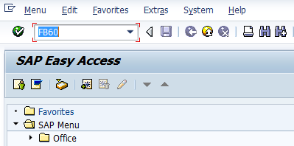
- Input FB60 in Transaction box and press Enter key

Document Header Data Information
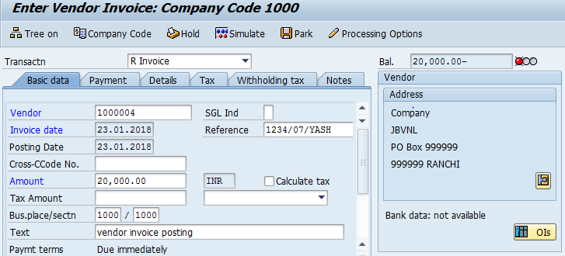
The following are the Input fields under the Document Header data of Vendor Invoice
- Vendor: Input the Vendor Number in the Vendor field with help of press “F4” button to search vendor number.
- Invoice Date: Input the Invoice date in the field
- Posting Date: Input the transaction date in the Posting date field
- Currency: Input the Currency INR in the Currency field
- Reference: Input the Reference field with Reference (invoice) number
- Text: Input the Text Information in text field Eg: Vendor invoice posting with Tax
- Calculate Tax: Check the Calculate Tax check box for calculating tax. Select respective tax from drop down list Eg: C3 5% VAT+1% TCS
- Section Code: Input the Withholding tax section code in this field in case of TDS is applicable.
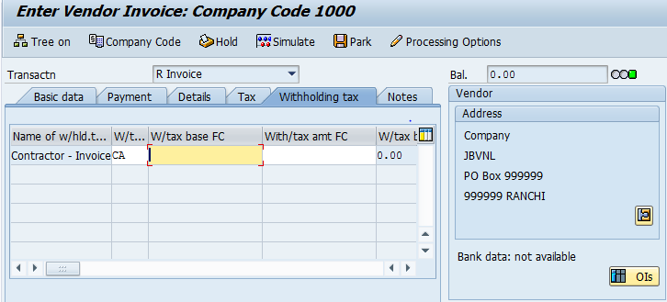
Withholding Tax/WCT Labour cess etc tax applicable: System will automatically populate the Withholding tax information as it was updated in Vendor Master Data. We can change the details of withholding tax if required.

Document Line Item Data
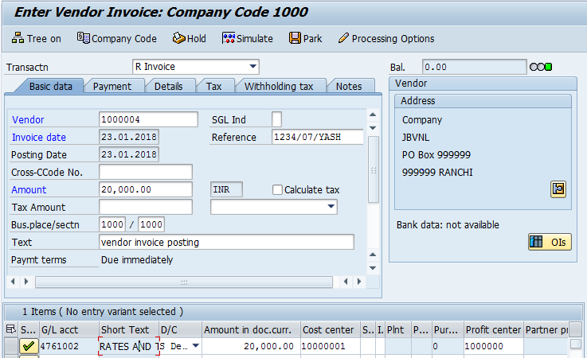
The following are the Input fields under the Line Item data to be filled.
- GL Account: Place the Cursor on the field and press F4. Select the respective GL Account and press Enter key
- Debit/Credit: Select Debit/Credit option from drop down list
- Text Field: Input the Text information e. g.: Vendor Invoice posting with Tax
- Cost Center: Place the cursor on the field and press F4. Select the respective Cost Center and press Enter key
- Profit Center: Profit Center will get automatically updated (through Cost Center Profit Center will get updated) as configured.

Simulation of Transaction before posting:
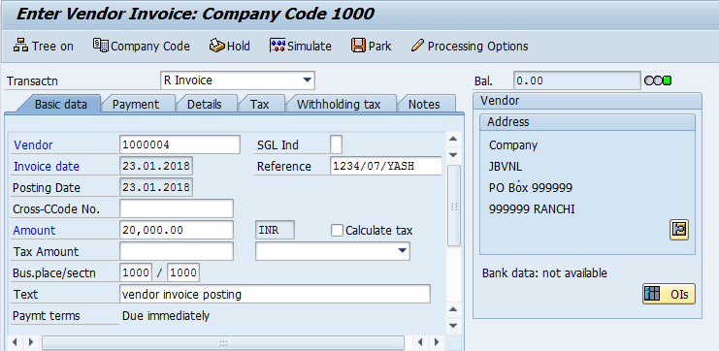
Simulate: Click on Simulate option. System will display the line items (Debit and Credit entry).
- Check the entries, if the entries are correct, click to Post Button
- If the entries are not okay, then go to main screen and take required action to correct it.
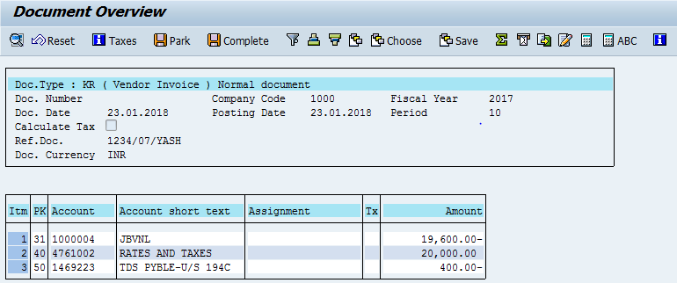
Click on Save icon

Document Posting
- Document is posted, An information will be populated at the bottom of the screen

Document Display View
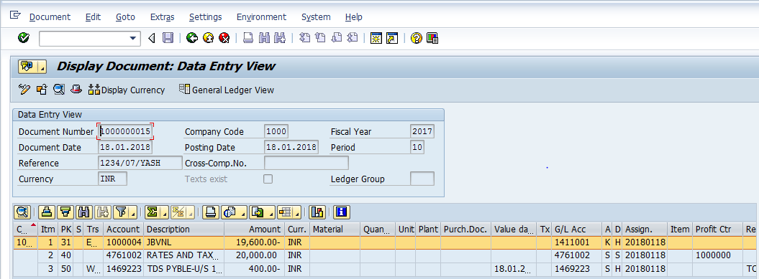
We can view the transaction in two ways:
- Display Document: From Menu bar select Document option it will display the options Change, Display, Post and Save as completed. Choose Display option. Document successfully got posted will get displayed
- Input FB03 in Transaction box and system will take us to Document Display screen. Input the Document number and Press Enter key. Document posted will get displayed.

Manual End

